82-2-675-5700 fax 675-0576
mailto : tmc@tmc.co.kr
homepage ; http://tmc.co.kr/
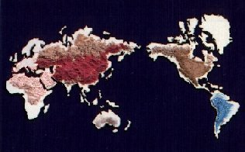

Tri Basic Copper Chloride

Specification

Item | Unit | Specification
Copper(Cu) Content | Min % | 58
Moisture | % | 0.05
Lead(Pb) Content | Max % | 0.004
Arsenic(As) Content | Max % | 0.003
Cadmium(Cd) Content | Max % | 0.001
Mercury(Hg) Content | Max % | 0.00002

Packing

- 25kg, Kraft paper bag, Inner Polyethylene film.
- 1,000kg Ton bag

